Risk Rating Key
Very Low/ Low/ Moderate / High / Very High

Activity | Hazard | Risk Assessment  (use Matrix) | Control Measure |  | Who | When
Supervising children in garden | Children being out of sight | Moderate | The garden must only be opened if there is an educator stationed in the garden whilst it is being used.  Children are informed that they need to wait for an educator to open the space before they can play.  Active supervision strategies are used by all educators.  Educators are to supervise following PAT – Position, Awareness & Teamwork. |  | All educators | Throughout the session
Using gardening tools | Children using tools incorrectly  Cuts, bruises | Moderate | Gloves are available for children who are using tools.  Children must wear closed in shoes.  Children are not to use adult size tools unless an educator has granted permission.  Tools are to be used only in the garden.  Children who are younger or who struggle with using tools will be monitored and assisted by educators.  Children who cannot follow the rules of the garden may be redirected to other spaces. |  | Educators / RP | Throughout the session
Bad weather | Falling tree branches, sun exposure, | Moderate | Staff are to follow the sun safe procedures enduring that children wear hats and use sunscreen in accordance with the UV rating.  Staff are to make record of any seemingly dangerous branches that are in proximity to the area upon completing the safety checklist.  If weather exceeds safe conditions educators will close the outdoor spaces. |  | Educators | Prior to session  Throughout session
Insects and animals | Stings/bites | High | The garden is to be kept clutter free to minimise risk of snakes or other harmful animals hiding. Children are encouraged to use gloves when digging and turning over sticks and rocks. Educators have checked the area and completed the safety checklist prior to the session.  First Aid trained Educators and First Aid Kits available during operational hours |  | Children/educators  Educators | During pack away time  Prior to session  During session
Completed by: Sean Higgins  Signature: Date: 11/09/2025 |  |  |  | Approved By:  Signature: Date:

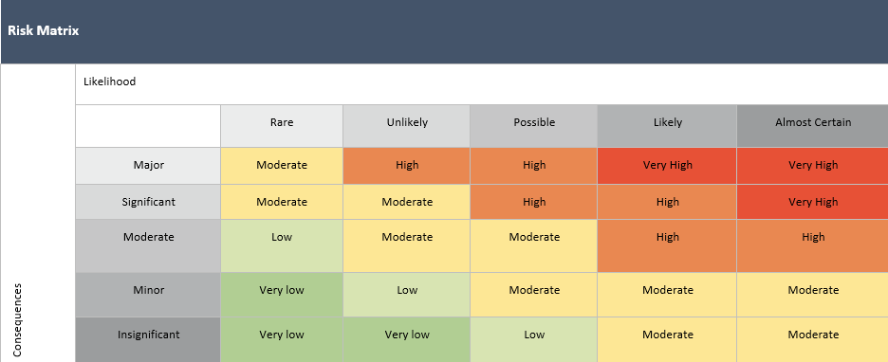

Risk Assessment Communication Record - (insert name) Risk Assessment

Educator/Staff Name | I have read and understood this Risk Assessment (tick) | Date & Signature | Educator/Staff Name | I have read and understood this Risk Assessment (tick) | Date & Signature

