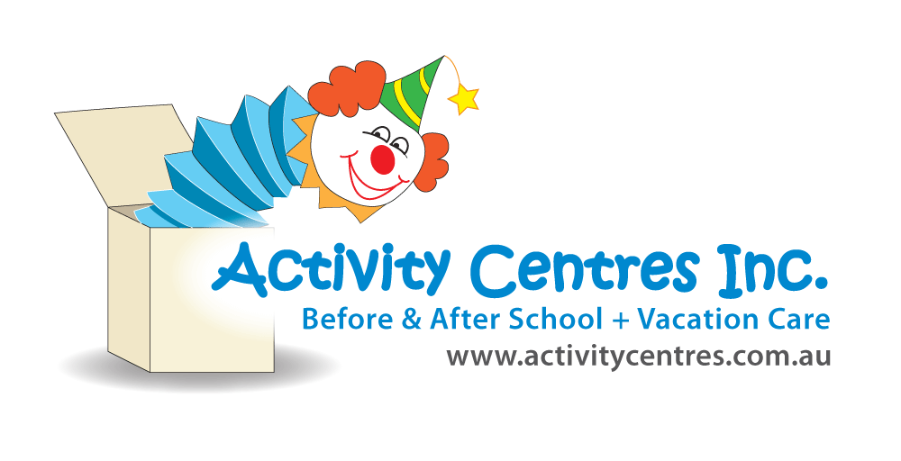

Risk Rating Key

**!! Very High**

**! High Risk**

**# Medium Risk**

**\* Low Risk**

**Messy Makers incursion** Risk Assessment

Lapstone Activity Centre

**Identified Hazard** –

* Making slime
* Behaviour

|  |  |  |  |
| --- | --- | --- | --- |
| **Risk**  **!** Ingesting products | **Control Measure**   * Messy Makers incursion uses nontoxic products, so will not cause harm if ingested. * Staff to be stationed evenly throughout group whilst incursion is in session. * Discussion prior to incursion around safety and using materials safely. * If materials are ingested, the child will be offered water to rinse mouth and parent will be notified as a courtesy. | | **Who is responsible**  Messy Makers/ RP  All educators & children “ “  “ “ |
| **\***Misuse of materials | * Discussion prior to incursion will outline expected behaviours and consequences for children who do not use equipment safely (will be removed from experience.) * Educators to be evenly stationed throughout group to monitor how children are using materials and equipment * Messy Makers employees to share any safety requirements prior to incursion beginning | | Educators  Educators  Messy Makers |
| Completed by: Jessie McCulloch    Signature: Date: | | Approved By: Kim Salmon  Signature: Date: | |

|  |
| --- |
| **Risk Assessment Communication Record for Messy Makers** |

|  |  |  |  |  |  |
| --- | --- | --- | --- | --- | --- |
| Educator/Staff Name | I have read and understood the above mentioned Risk Assessment (please tick) | Date & Signature | Educator/Staff Name | I have read and understood the above mentioned Risk Assessment  (please tick) | Date & Signature |
|  |  |  |  |  |  |
|  |  |  |  |  |  |
|  |  |  |  |  |  |
|  |  |  |  |  |  |
|  |  |  |  |  |  |
|  |  |  |  |  |  |
|  |  |  |  |  |  |
|  |  |  |  |  |  |
|  |  |  |  |  |  |
|  |  |  |  |  |  |
|  |  |  |  |  |  |
|  |  |  |  |  |  |
|  |  |  |  |  |  |