# Risk assessment and management template - Excursions

Approved providers, nominated supervisors and family day care educators must ensure a risk assessment is carried out before children are taken outside the service premises on an excursion. Prior authorisation must also be obtained from parents or other authorised nominees.

ACECQA has prepared this template to assist services in undertaking risk assessments before children leave the service premises as part of an excursion*,* which services may wish to incorporate within their own risk assessment material.

Regulation 101 of the Education and Care Services National Regulations includes the minimum risk assessment considerations for excursions, including specific considerations when an excursion involves transporting children.

*Note:* A risk assessment is only required to be completed at least once for a 12 month period if the excursion is a ‘*regular outing*\*’.

*Regular outing: means a walk, drive or trip to and from a destination that the service visits regularly as part of its educational program, and where the circumstances relevant to the risk assessment are substantially the same on each outing.

|  |  |  |
| --- | --- | --- |
| **Lapstone Activity Centre- Risk assessment – Monkey Mania** | | |
| **Service Name** | **Lapstone Activity Centre (LAC)** | |
| Excursion details | Monkey Mania | |
| **Date (s) of excursion.**  If it is a regular outing include a description of when children are to be taken on regular outings. | Thursday 10/7/2025 | |
| **Proposed activities.**  List all activities that will take place during the excursion. | - Bus travel   - Using the Monkey Mania play equipment | |
| **Pick up location and destination (s).**  List each location travelled to and from as part of the excursion.  E.g., the museum, park for lunch and service. | Pick up from Lapstone Public school, 65 Explorers road, Lapstone, 2773  Arrive at Monkey Mania ,8 Tindale St, Penrith NSW 2750  Return to Lapstone Public school | |
| **Estimated departure and arrival times and duration of the excursion.**  E.g., from the service to each destination and returning to the service. | Travel times are approximates  Pick up at LAC - 10am  Arrive at Monkey mania - 10.30am  Pick up from monkey mania 11:30am Return to LAC at 12:00pm | |
| **Proposed route**  You can include an image of the route sourced online. | Refer to maps attached | |
| **Means of transport**  E.g., public bus, private bus, coach, private car, taxi, tram | Charted bus – Penrith mini bus | |
| **Requirements for seatbelts or safety restraints in your state or territory have been met.** | Yes / No  Comment: | |
| **Number and full names of each adult involved in the excursion.**  E.g., service staff, family members, volunteers |  | |
| **The number of educators / responsible adults, appropriate to provide supervision, and whether any adults with specialised skills are required.**  E.g. for children’s individual needs. | 3  Minimum 1 first aid trained staff member | |
| **The number of children involved in the excursion.** | 30 | |
| **Any water hazards during the excursion, including any risks associated with water-based activities?**  If yes, detail in the risk assessment table below. | Yes / No  Comment: | |
| **Educator to child ratio, including whether this excursion warrants a higher ratio.**  Provide details in the risk assessment table below. | 1:10 | |
| **Describe the process for entering and exiting the service premises and the pick-up location or destinations (as required); (include how each child is accounted for):**  Children will be provided with their blue Excursion T-shirt and coloured wristband with services mobile phone number upon arrival at the Centre.  A Roll Call will be conducted before leaving the Centre.  Once all children are accounted for, the children will line up and walk with Educators (one Educator must be at the front of the group, one Educator must be at the back of the group and the rest of the Educators to walk spaced throughout the group of children). The children and Educators will walk along the assigned footpath in School grounds and out of small back gate to where the Bus will be waiting in the small back carpark. If the group needs to walk up to the Bus, the children must walk on the footpath and not on the council strip to the Bus. The Educators must be spaced out between the group of children and walk on the closest to the road.  When leaving the Service the time and Educator’s signature will be recorded on the Children’s Signed In and Out of Transport Document as the children embark.  Upon returning to the Service the time and Educator’s signature will be recorded on the Children Signed In and Out of Transport Document as the children disembark. The group will enter the small side gate and walk along the footpath next to the Canteen to reach the Service.  **Children Signed In and Out of Transport document** will record day, date, child’s name, time and signature of Educator accounting for children embarking the Bus and time and signature of Educator accounting for children disembarking the Bus. | | |
| **Describe the procedures for embarking and disembarking the vehicle (include how each child is accounted for in embarking and disembarking):**  Each child will be accounted for when embarking and disembarking the Bus by an Educator marking them off on the Children Signed In and Out of Transport document. The time, name and signature of the person who accounted for the children who embarked and disembarked appears on this document.  When embarking the children will line up at the Bus and as the Educator writes the time and their signature next to the child’s name the child will then board the Bus.  When disembarking the children will walk down the Bus steps one child at a time as the Educator writes the time and their signature next to the child’s name.  The children will line up in designated area until the process has been completed and the Bus has been checked.  A Head Count will be conducted by other Educators to ensure the number of children disembarking corresponds with the number of children lining up after disembarking. | | |
| **Excursion checklist – items to be readily available during the excursion**  **(Please tick)** | | |
| □ First aid kit | | □ List of adults involved in the excursion |
| □ List of children involved in the excursion | | □ Contact information for each adult |
| □ Contact information for each child | | □ Mobile phone / other means of communicating with the service & emergency services |
| □ Medical Management Plans, Medication & RMP for individual children | | □ Other items, please list   * 4G Ipad * Transport Policy – Safe Transportation of Children. * First Aid Policy. * Emergency Policy. * Accurate current attendance records. * Risk Assessment and Management - Single Trip Transportation of Children Safety Checklist * Risk Assessment and Management – Children Embarking and Disembarking the Vehicle for Single Trip Transportation |

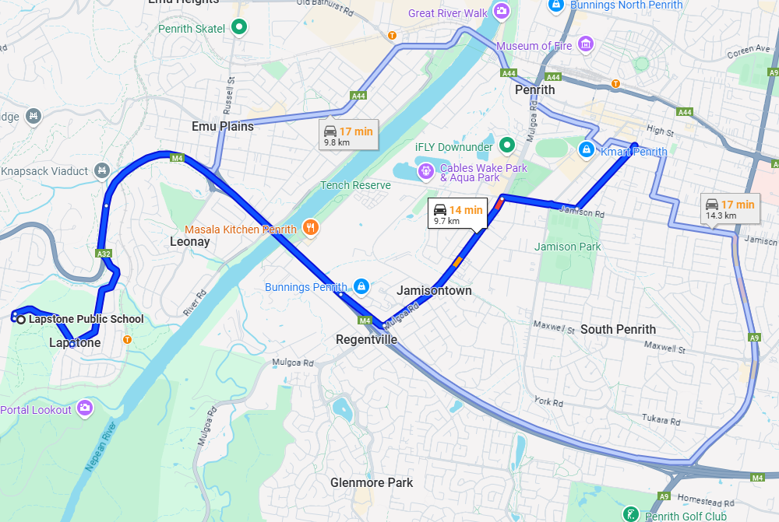

Use the table below to identify and assess risks to the safety, health or wellbeing of children attending the excursion, and specify how these risks will be managed and minimised (regulation 101(1)). This must include any risks associated with water-based activities.

Risk Rating Key

**!! Very High**

**! High Risk**

**# Medium Risk**

**\* Low Risk**

**Identified Hazard** –

Transport

* Bus and Driver – qualified and vehicle registered
* Travelling in the Vehicle
* Children embarking and disembarking
* Documentation not completed correctly

|  |  |  |
| --- | --- | --- |
| **Risk**  **\*** Driver is unqualified  **\*** Bus is unregistered  **\*** Safety equipment is not operational  **\*** Onboard fire  **#** Walking to Bus  **!** Trips/falls when embarking | **Control Measure**   * As per our Policies and Procedures, Education and Care Services National Regulations and Law and WHS Regulations and Law – * Bus company provides correctly qualified driver for size of vehicle. * Ensure Bus is registered * Every fire extinguisher fitted in a commercial vehicle will be of a type with a hose to assist in gaining access to awkward locations * If a fire occurs, Bus Driver must immediately stop the Bus and with Educators get all passengers safely off the Bus. Driver will assess situation and if safe, will use fire extinguisher. Educator to contact Service as soon as practicable to report incident. Service to contact Head Office ASAP. * Educators ensure children walk along footpath in single line to Bus to make embarking Bus smoother. * Educators actively supervise children and monitor footpath for hazards while walking together along footpath. | **Who**  Bus company  Bus Company & Coordinator  Bus Company  Driver and Educators  Educators  Educators |
| **!** Trips/falls when embarking  **!** Injury due to non-use or incorrect use of restraint  **#** Vehicle breakdown or malfunction  **!** Crash involvement | * Educators physically assist children to embark where required. * Educators visually monitor and check that children are correctly wearing seat belts. * If child is not wearing seat belt whilst bus is in motion, the bus will be stopped until seat belt is correctly worn. * Keep children on bus if safe to do so. If not move children to a safe location protected from oncoming traffic, sun and heat. * Educators to supervise children to avoid danger until problem is fixed or replacement bus arrives. * Educator to contact Service as soon as practicable. Service to contact Head Office ASAP. Children encouraged to have full water bottles in case of an incident. * Objects are safely stowed and secured in vehicle to minimise movement in a crash. * Charged mobile phone and contact numbers carried on board. * Educators have current first aid, asthma and anaphylaxis training. * Bus Driver and Educators will assist all passengers safely off the Bus. * Educators will move children to a safe area (if able to move children). * Educator will provide First Aid (if required). * Educator to contact Emergency Services (if required). * Bus Driver to contact Bus Company. * Educator to contact Service as soon as practicable to report incident. * Service to contact Head Office ASAP. | Educators  Educators  Educators & Child  Educators  Educators  Educators, Bus Driver & Service |
| **!** Trips/falls when disembarking | * Educators physically assist children to disembark where required. | Educators |
| **!** Educators do not follow ACI Transport Policy-Safe Transportation of Children when children embark the vehicle | * Procedures to be carried out by Educators when children embark the vehicle   Educators will:   * mark each child’s name off the Children Signed In and Out of Transport document as children embark the vehicle * record time of the child embarking and Educator’s signature * conduct headcount | Educators |
| **!** Educators do not follow ACI Transport Policy-Safe Transportation of Children when children disembark the vehicle | * Procedures to be carried out by Educators when children disembark vehicle   Educators will:   * mark each child’s name off the Children Signed and Out of Transport document as children disembark the vehicle * record time of the child disembarking the vehicle and Educator’s signature * conduct head count * conduct vehicle check to ensure no child remains in the vehicle | Educators |
| Documentation not completed and signed off by Educator | * Educator must complete all required documentation as per ACI Transport Policy-Safe Transportation of Children | Educator completing documents |

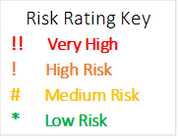

**Identified Hazard –**

* Child protection issues
* Medical emergencies
* Monkey Mania safety
* Child inappropriate behavior

|  |  |  |
| --- | --- | --- |
| **Risk**  **!!** Children being abducted/leaving location | **Control Measure**   * As per our Policies and Procedures, Education and Care Services National Regulations and Law and WHS Regulations and Law – * Children informed prior to leaving the service of what to do if they become lost from the group. * Children all provided with a blue excursion shirt which has service contact details on it, to assist staff in maintaining supervision. * Head count taken on a regular basis especially when moving around. * Coloured wrist bands provided to identify which service the child belongs to. * Educator to be stationed near entrance/exit * Search immediate area. * Coordinator/Educators to coordinate searchers and search area. * Notify Emergency Services e.g., police, fire, ambulance. * If missing child not found within reasonable time contact Head Office. * Head Office to notify parents. | **Who**  Responsible Person  “ “  All Educators  Responsible Person  Responsible Person |
| **!** Children becoming separated from group | * Children will be informed to stay with educators at all times and what to do if they become separated from the group. * Educators not to leave children unattended at venue and to ensure all children stick together in their group. * All children will be in blue Excursion T-shirt – this shirt must be visible – which has centre phone number on it. * Children will be in groups throughout the day, with Educators. All Educators will be provided with a list of children who are in their group. Regular head counts and roll calls to be done throughout the day to ensure all children are present and accounted for. * Educators to have service mobile phones on them to ensure ongoing communication between groups. * Coloured wrist bands to have service mobile phone number on them | Responsible Person  All Educators  Responsible Person  All Educators  Responsible Person |
| **!!** Child protection issues | * Supervision at all times to ensure that at no time driver or member of public is alone with an individual or group of children in our care. * Educator to accompany groups of children to toilets throughout the excursion – no child is to go unaccompanied. * Educators to check toilets prior to children entering to ensure there is no individuals lurking, etc.… * Report any suspicious behaviour to Excursion Supervisor – always maintain active supervision.   If approached –   * Keep still and do not make sudden moves. * Do not use phone in perpetrator’s presence. * Obey perpetrator’s instructions. * Observe perpetrator’s appearance. * Allow perpetrator to leave but do not follow. * Educators are to ensure children stay in designated area and not engage in conversations with strangers. * Notify Emergency Services. | All Educators  All Educators  All Educators  All Educators and children |
| **!** Child experiencing Asthma, Allergic or Anaphylactic reaction | * List of children with Medical Conditions is taken on Excursion. * Each child’s Medication Box to be taken which contains – Medical Management Plan, Medication Form and Medication. * Educators are to be aware which children have Medical Management Plans. * Educator who is holding child’s medication is in the same group as child, and that this Educator has the appropriate qualifications to administer (Asthma/Anaphylaxis). * Ensure Educators are vigilant in minimising risk on the day and ensuring children are not, to the best of our ability, exposed to known allergens. | Responsible Person  All Educators  All Educators  All Educators |
| **!** Bumps, scrapes, bruises, cuts, fracturs, breaks.  **!!** Concussion | * Safety Rules are discussed with children before the Excursion. * Educators are to supervise using Position Awareness Teamwork (PAT). * Hazards – eliminated, sectioned off or totally avoided. * Educators are to ensure children follow instructions from Monkey Mania staff * Children who cannot follow the safety guidelines will be given 2 warnings and will be removed from the activities if warnings have been given. * Fully stocked first aid kit taken * Emergency numbers packed | Responsible Person  All Educators  Responsible Person |

|  |  |  |  |
| --- | --- | --- | --- |
| **Plan prepared by:** | Full Name: Sean Higgins | | Date: |
| Signature: | |
| Role/Position: Responsible Person | |
| **Prepared in consultation with:** | Full Name: Jessie McCulloch | | |
| Signature: | | |
| Role/Position: LAC Coordinator | | |
| **Communicated to relevant staff:** | Yes/No | | |
| **Write names of Educators communicated to** See communication page attached | Comment if needed: | | |
| **Vehicle safety information reviewed and attached** | |  | |
| **Risk assessment to be evaluated and reviewed on:**  **A risk assessment must be undertaken prior to an excursion being undertaken (and before seeking authorisation for that excursion to be undertaken - see regulation 102). If the excursion is a 'regular outing'*, a risk assessment must be undertaken at least annually.** | |  | |

**Risk Matrix**

Use the risk matrix to determine the Risk Rating for the activity or area being assessed.

|  |  |  |  |  |  |  |
| --- | --- | --- | --- | --- | --- | --- |
|  | **IMPACT** | | | | | |
| **Likelihood** |  | **Insignificant** | **Minor** | **Moderate** | **Major** | **Severe** |
| **Almost Certain** | Medium | High | High | Very High | Very High |
| **Likely** | Medium | Medium | High | High | Very High |
| **Possible** | Low | Medium | High | High | Very High |
| **Unlikely** | Low | Low | Medium | Medium | High |
| **Rare** | Low | Low | Medium | Medium | Medium |

|  |  |  |  |
| --- | --- | --- | --- |
| **Likelihood** | | **Impact** | |
| **Almost Certain** | Is expected to occur in most circumstances | **Insignificant** | Injuries not requiring first aid |
| **Likely** | Will probably occur in most circumstances | **Minor** | First aid required |
| **Possible** | Could Occur at some time | **Moderate** | Medical treatment required |
| **Unlikely** | Not likely to occur in normal circumstances | **Major** | Hospital admission required |
| **Rare** | May occur only in exceptional circumstances | **Severe** | Death or permanent disability to one or more persons. |