
Risk Rating Key
Very High
High Risk
Medium Risk
Low Risk
Gamerz and Games2U : Risk Assessment
Beresford Road Activity Centre

Activity | Hazard | Risk Assessment  (use Matrix) | Control Measure |  | Who | When
 |  |  | Staff will be required to read the Emergency Procedures Manual (EPM) in consultation with this Risk Assessment. |  | Coordinator | During Induction
 |  |  | As per our Emergency Procedures Manual & Flip Chart – 3.12 Medical Emergency and Flip Chart – Medical Emergency Page  Educators are to be aware and understand procedures to be followed. |  | All Educators | On activity day
 |  |  | As per our Emergency Procedures Manual & Flip Chart – 3.22 Missing Child  Educators are to be aware and understand procedures to be followed. |  | All Educators | On activity day
 |  |  | As per ACI Policies and relevant Regulations and Laws (Education and Care Services and WHS) –  Educators are to adhere to and enforce procedures set out in the following Policies  - Child Behaviour Management  - First Aid – Management of Incident, Injury, Illness and Trauma  - Supervision |  | All Educators | On activity day
Mobile Games Truck | Trips, slips, falls  Missing child  Electric shock | Medium  Medium  Medium | - The activity will be setup in the Car park Area or Infants Cola area or any other area deemed safe by Responsible Person. Responsible person to risk assess the area.  - Educators on site are First Aid trained and First Aid Kits fully stocked.  - Phones, Walkie Talkies and Ipads to be charged for each Session.  - Children to be sent in groups to participate in the activity. Groups are numbered according to number of children attending for the day.  - Children reminded of the Be Safe, Be Responsible & Be Respectful rules.  - Educators are to ensure following Safety Check is completed for truck before the start of the activity.  - Educator to check the entry to truck has no obstruction and is safe.  - Check the perimeter is clearly marked by organiser using witches hats / cones  - The organiser will provide age appropriate games only  - The inside of truck does not have any hanging cords or unsafe cords.  - Children to be escorted to the truck and back by an Educator, Educator to do a headcount of children each time.  - While accessing the truck children are to stand in a line on one side. Entry and Exit points to be clearly explained to the children for the activity.  - Any children not following the rules will not be permitted to play for a period of time. If behaviour continues they will not be permitted to continue play for the rest of the day. |  | Responsible Person  Responsible Person  All Educators  Responsible Person  All Educators  All Educators  All Educators  All Educators  All Educators | On activity day  On activity day  On activity day  On activity day  On activity day  On activity day  On activity day  On activity day  On activity day
Outdoor Laser Tag | Due to accidental contact, wet weather  Trips, slips, falls, collision  Cuts, scrapes  Bumps, bruises  Laceration / puncture wounds  Missing child | Medium Risks | - The activity will be setup in the area deemed safe by Responsible Person. (example Oval) Responsible person to risk assess the area  - In Wet weather area of play to be reassessed.  - Phones, Walkie Talkies and Ipads to be charged for each Session.  - Children reminded of the Be Safe, Be Responsible & Be Respectful rules.  - Educators are to ensure Safety Check is completed of area before the start of the activity.  - Educators to make sure the area has no obstructions that can cause a trip hazard.  - Any obstructions need to be removed. If unsafe the activity is not to go ahead.  - If moving obstacles while setting up area, Educators are to use correct manual handling skills to minimise personal injury and avoid lifting heavy objects alone.  - When children are assisting in setup, ensure children are using correct manual handling and not attempting to lift heavy objects alone.  - The area of play should be even and dry with no sticks/twigs to avoid slips and trips. The area to be swept if needed.  - Children to be sent in groups to participate in the activity. Groups are numbered according to number of children attending for the day.  - Children to be escorted to the activity and back by an Educator, Educator to do a headcount of children each time. Entry and Exit points to be clearly explained to the children for the activity.  - Laser Tag is a non-contact activity. Before start of activity the organisers will explain the movement rules of the game.  - The organiser will show children the appropriate way to hold/grip the laser tagger to avoid lacerations / puncture wounds  - Children who do not follow rules and are causing harm to other children will not be allowed to play the game  - Children to wear appropriate sun protection throughout the day following the Sun Protection policy  - Children with enclosed shoes will be allowed to participate in the activity  - Educator to remind children of speed during the play |  | Responsible Person  Responsible Person  All Educators  All Educators  All Educators  All Educators  All Educators  All Educators  All Educators  All Educators  Responsible Person  All Educators  Games2U Coordinator  Games2U Coordinator  All Educators  All Educators  All Educators  All Educators | On activity day  On activity day  On activity day  On activity day  On activity day  On activity day  On activity day  On activity day  On activity day  On activity day  On activity day  On activity day  On activity day  On activity day  On activity day  On activity day  On activity day  On activity day
Giant Yard Games (include : Corn Hole , Connect 4, Noughts and Crosses, Coits, Snakes and Ladders | Trips, slips, falls  Bumps, bruises  Missing child | Medium Risks | - The activity will be setup in an area deemed safe by Responsible Person. Responsible person to risk assess the area  - Educators on site are First Aid trained and First Aid Kits fully stocked.  - Phones, Walkie Talkies and Ipads to be charged for each Session.  - Children to be sent in groups to participate in the activity. Groups are numbered according to number of children attending for the day.  - Children reminded of the Be Safe, Be Responsible & Be Respectful rules.  - Educators are to ensure Safety Check is completed for area before the start of the activity.  - Children to be escorted to the activity and back by an Educator, Educator to do a headcount of children each time. Entry and Exit points to be clearly explained to the children for the activity.  - Children to wear appropriate sun protection throughout the day following the Sun Protection policy  - Children unable to follow set rules will not be permitted to play for a period of time. If behaviour continues they will not be permitted to continue play for the rest of the day. |  | Responsible Person  All Educators  All Educators  Responsible Person  All Educators  All Educators  All Educators  All Educators  All Educators | On activity day  On activity day  On activity day  On activity day  On activity day  On activity day  On activity day  On activity day  On activity day
Giant Hamster Ball | Bumps, bruises  Dizziness  Missing child  Strong winds | Medium Risks | - The activity will be setup in the area deemed safe by Responsible Person. (example Oval) Responsible person to risk assess the area  - Children to be sent in groups to participate in the activity. Groups are numbered according to number of children attending for the day.  - Children to be escorted to the activity and back by an Educator, Educator to do a headcount of children each time. Entry and Exit points to be clearly explained to the children for the activity.  - Children to wear appropriate sun protection throughout the day following the Sun Protection policy  - Children unable to follow set rules will not be permitted to play for a period of time. If behaviour continues they will not be permitted to continue play for the rest of the day.  - Children will be asked if they wish to participate or not  - Educator to do a safety check of the area  - Activity will not commence in strong wind at the risk of the balls blowing the participant off course |  | Responsible Person  Responsible Person  All Educators  All Educators  All Educators  All Educators  All Educators  All Educators | On activity day  On activity day  On activity day  On activity day  On activity day  On activity day  On activity day  On activity day
Completed by: Tara Sheather  Signature: Date: 13/11/2025 |  |  |  | Approved By: Margaret Saldanha  Signature: Date: 13/11/2025

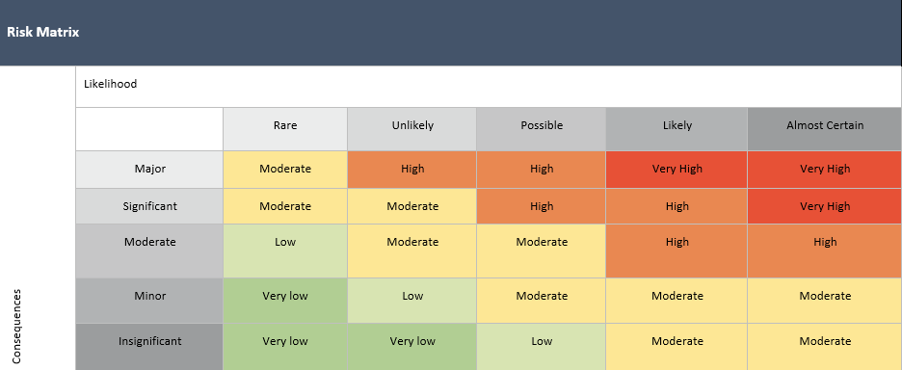

Likelihood |  | Impact
Almost Certain | Is expected to occur in most circumstances | Insignificant | Injuries not requiring first aid
Likely | Will probably occur in most circumstances | Minor | First aid required
Possible | Could Occur at some time | Moderate | Medical treatment required
Unlikely | Not likely to occur in normal circumstances | Major | Hospital admission required
Rare | May occur only in exceptional circumstances | Severe | Death or permanent disability to one or more persons.

Risk Assessment Communication Record - Gamerz and Games2U

Date of Review: | Person/s who completed Review: |  | Date of Review: | Person/s who completed Review:
Changes Made: YES / NO |  |  | Changes Made: YES / NO
Notes: |  |  | Notes:
Educator/Staff Name | I have read and understood this Risk Assessment (tick) | Date & Signature | Educator/Staff Name | I have read and understood this Risk Assessment (tick) | Date & Signature

