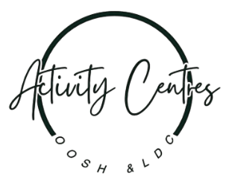
Incursion Inflatable Games: Risk Assessment
Beresford Road Activity Centre

Risk Rating Key
Very High
High Risk
Medium Risk
Low Risk

Activity | Hazard | Risk Assessment  (use Matrix) | Control Measure |  | Who | When
 |  |  | Staff will be required to read the Emergency Procedures Manual (EPM) in consultation with this Risk Assessment. |  | Coordinator | During Induction
 |  |  | As per our Emergency Procedures Manual & Flip Chart – 3.12 Medical Emergency and Flip Chart – Medical Emergency Page  Educators are to be aware and understand procedures to be followed. |  | All Educators | On activity day
 |  |  | As per our Emergency Procedures Manual & Flip Chart – 3.22 Missing Child  Educators are to be aware and understand procedures to be followed. |  | All Educators | On activity day
 |  |  | As per ACI Policies and relevant Regulations and Laws (Education and Care Services and WHS) –  Educators are to adhere to and enforce procedures set out in the following Policies  - Child Behaviour Management  - First Aid – Management of Incident, Injury, Illness and Trauma  - Supervision  - Sun Protection  - Water Safety Policy |  | All Educators | On activity day
Water Slide  Obstacle Course  Jumping Castle | Trips, slips, falls – sprains, fractures, bruises  Bumps  Collision | Medium Risks | - The activity will be setup in the Main Cola Area or Infants Cola area or any other area deemed safe by Responsible Person. Responsible person to risk assess the area.  - Organiser to explain what to do in the event of an emergency (if inflatable losses air and deflates while in use )  - Educators on site are First Aid trained and First Aid Kits fully stocked.  - Phones, Walkie Talkies and Ipads to be charged for each Session.  - Children to be sent in groups to participate in the activity. Groups are numbered according to number of children attending for the day.  - Groups to be formed comprising of following ratio (to be assessed on day based on children attending).  - For Water Slip n Slide 1 Educator : 10 - 15 children  - For Jumping Castle 1 Educator : 8 Children  - For Obstacle Course 1 Educator : 8 Children  - Children reminded of the Be Safe, Be Responsible & Be Respectful rules.  - Educators are to ensure following Safety Check is completed for truck before the start of the activity.  - Check the perimeter is clearly marked by organiser using witches hats / cones.  - Entry and exit points are identified  - Check for Loss of air to inflatable item. If any loss of air, Educator to stop play and notify Responsible person.  Before and During Play  - While accessing the equipment children are to stand in a line on one side. Entry and Exit points to be clearly explained to the children for the activity.  - Children are to access the equipment barefoot. Shoes to be lined up neatly in area designated for placing shoes.  - Educators will discuss the rules with children before commencement of the activity.  - Educator to maintain number of children using the inflatable and ensure it is not overcrowded  - Children unable to follow set rules may be asked to leave the activity  - For Water Slip n Slide  - Max 4 children to access the inflatable at a time. The rest of the children stand in the line waiting for their turn. Educator to reassess the numbers on the day depending on the children participating.  - For slide :  - only 1 – 2 child at a time to climb up the stairs and down the slide. Children to wait for go from educator before sliding. Educator to position themselves near the end of slide area. Educator to assist child out of area if needed. Educator to reassess the numbers on the day depending on the children participating.  - Children are always seated, and slide Feet first , Sitting down  - Children are not jumping  - No pushing up stairs to top of slide  - No crowding at top of slide  - Accessing/Exiting Inflatable  - Sitting down to exit inflatable  - No Jumping off any steps that are on the inflatable  - No diving into any inflatable obstacles located at entrance/exit  - No summersaults/backflips when exiting or entering.  - Educators are to supervise following PAT – Position, Awareness & Teamwork  - Educators to supervise children, any children showing any distress, are to be removed from the environment instantly. Wherever possible, reason for distress established and remove or resolve issue to allow child to re-enter play |  | Responsible Person  Vacation Care Coordinator  Responsible Person  All Educators  All Educators  All Educators  All Educators  All Educators  All Educators  All Educators  All Educators  All Educators | Prior to activity  Prior to activity  Prior to activity  Prior to activity  On activity  On activity  On activity  On activity  On activity  On activity  On activity  On activity
Water Slide  Obstacle Course  Jumping Castle | sunburn, sunstroke and dehydration | Medium Risk | - Educators and children must wear hats when UV is rated 3 and over.  - Educators and children must wear Sunscreen when UV is rated 3 and over. Applied and reapplied as per manufacturer’s instructions. |  | All Educators  All Educators | On activity  On activity
Water Slide | Medical conditions such as grommets | Medium Risk | - Parents/Guardians will be asked to inform us if there are any conditions we need to know about in relation to their child and water play.  - A list will be compiled of all children with any medical conditions which may affect water play and distributed to all staff so that they are aware of any issues affecting the children. It will include all wishes/instructions that parents and Guardians have outlined to manage condition (e.g.–grommets–ensure child wears earplugs). This list will be made available to all educators prior to activity.  - All educators are to familiarise themselves with above list and which children need to be assisted on the day and ensure family instructions are followed. |  | Vacation Care Coordinator  Vacation Care Coordinator  All Educators | Prior to activity  Prior to activity  On activity
Water Slide  Obstacle Course  Jumping Castle | Inflatable looses air and collapses on children - suffocation | Very High Risk | - Educator to constantly monitor inflatable pump is working  - Educator to supervise children are not in the area where the pump is installed  - Make sure power connection to pump is secure and covered |  | All Educators | On activity
Water Slide  Obstacle Course  Jumping Castle | Extreme weather  - Strong wind blows ride over, or away  - Strong wind lifts ride placed on hard surfaces  - Rain causes wet surfaces, slipping | High Risk | - The activity will be closed down in extreme weather conditions  - Organiser places Pegs or Sandbags or concrete blocks on ALL anchor points.  - Monitor windspeed. Cease operation if winds > 30k/h  - Cease operation until surface is dried |  | All Educators | On activity
Completed by: Tara Sheather  Signature: Date: 13/11/2025 |  |  |  | Approved By: Margaret Saldanha  Signature: Date: 13/11/2025

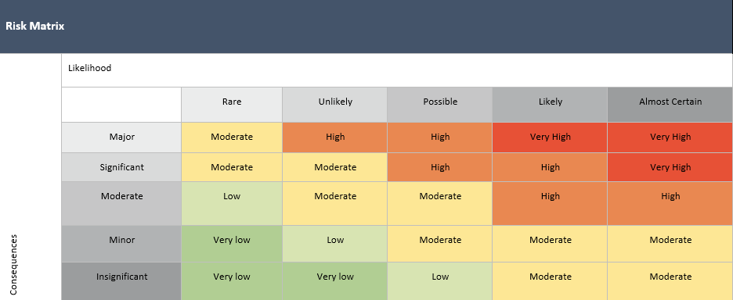

Likelihood |  | Impact
Almost Certain | Is expected to occur in most circumstances | Insignificant | Injuries not requiring first aid
Likely | Will probably occur in most circumstances | Minor | First aid required
Possible | Could Occur at some time | Moderate | Medical treatment required
Unlikely | Not likely to occur in normal circumstances | Major | Hospital admission required
Rare | May occur only in exceptional circumstances | Severe | Death or permanent disability to one or more persons.

Risk Assessment Communication Record - Inflatable Games

Date of Review: | Person/s who completed Review: |  | Date of Review: | Person/s who completed Review:
Changes Made: YES / NO |  |  | Changes Made: YES / NO
Notes: |  |  | Notes:
Educator/Staff Name | I have read and understood this Risk Assessment (tick) | Date & Signature | Educator/Staff Name | I have read and understood this Risk Assessment (tick) | Date & Signature

