
Risk Rating Key
Very Low , Low, Moderate , High , Very High
Technology Usage Risk Assessment
Beresford Road Activity Centre
Activity | Hazard | Risk Assessment  (use Matrix) | Control Measure |  | Who | When
Children using devices / School computers | Exposure to inappropriate content | High | - Only educators will have passcodes to download games and apps and will ensure the “G” or approved “PG’ rating of games before downloading.  - If children are surfing the web or going on YouTube, permission for sites must be sort- sites will be locked and access will only be granted once deemed appropriate.  - Technology is to be used in a common room (Hub of BRAC) to ensure that they can be closely monitored by educators at all times  - All Technology will be password protected with access for educators only to enter or access  - Children will not be left unsupervised when accessing the internet.  - Where possible all devices will be set up with safety measures – this will include having child-safe browsers meant for kids, control settings and safe search settings.  - Personal digital devices will be monitored during vacation care times and educators reserve the right to ask for inappropriate rated games/ videos to not be played while in attendance at the centre.  - Children’s personal devices will not be able to connect to BRAC internet connection.  - Children will not be permitted to take photos or videos of other children on personal devices at any time.  - No chat sites or interactive games will be allowed to be downloaded on any devices eliminating the risk of children being able to text/chat/connect to others.  - Children who have personal mobile phones must always keep their device in their bag unless permission has been given by an educator.  - Educators may confiscate children’s personal devices if inappropriate use is occurring  - During use of computers in computer room, children to access sites that are permitted by school, no access to emails, inappropriate games. |  | All educators  All educators & Families  All educators  Responsible Person  All educators  Head office  All educators  All educators  Children & educators  All educators  All educators & Children  Educators & Children  Educators & Children | At all times  At all times  During use  At all times  During use  As needed  During use  At all times  At all times  At all times  At all times  As required  At all times
Loss or damage to personal or center-owned devices | Financial loss, data security concerns | Moderate | - Children must be sitting whilst using tech  - Personal tech will be stored safely when not in use  - Personal tech is encouraged to be brought in with a hard cover case for additional protection |  | Children  Children  Children & Families | During use  After use  Prior to bringing tech
Inappropriate children’s behaviour | Cyberbullying or peer conflict | High | - Where able Use of parental controls and filtering software to block inappropriate content.  - Access limited to approved apps, games, or educational websites.  - No social media platforms or open internet browsing unless directly supervised and purpose-driven.  - Block social media sites  - Educate children on digital safety  - Staff training in cyber safety |  | Head office  Responsible person  All educators  Responsible Person  All educators  Head office | As needed  At all times  At all times  At all times  As needed  As needed
Privacy breach (photos, location, personal info) | Child safety risk | High | - Prohibit photo sharing  - Disable GPS/location features  - No personal account logins by educators  - Review app permissions |  | Responsible person  Responsible person  All educators  Responsible Person | At all times  At all times  At all times  As needed
Staff use of devices (personal or service mobile phones, ipads) | Sharing images of children  Sharing personal information | Moderate | - Staff are not to use their personal phones to take photos or videos of children  - Staff to keep personal devices in their bags during their shifts. Unless written authorisation is obtained  - Staff to communicate with coordinator if they require their phones for emergencies  - Work applications should not be downloaded on personal devices  - ACI policy will reflect safe use of technology and strict guidelines |  | All educators  All educators  All educators  All educators  Head office | At all times  At all times  As needed  At all times  At all times
Limited Esafety knowledge by children | Children not understanding risks associated with tech | Moderate | - Where possible, we will incorporate technology safety learning into our Educational program  - We will advertise community links for families in regard to Esafety  - Educators to reflect upon safe use of technology and how we can support children to be safe online & with tech |  | Educational Leader  Responsible Person  All educators | As needed  As needed  As needed
Completed by: Margaret Saldanha  Signature: Date: 11/9/25 |  |  |  | Approved By: Tara Sheather  Signature: Date: 11/9/25

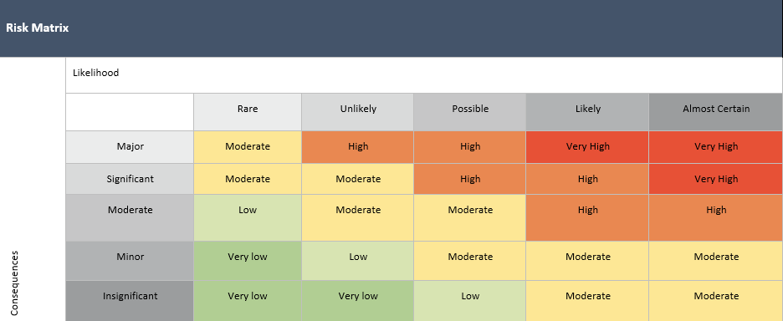

Likelihood |  | Impact
Almost Certain | Is expected to occur in most circumstances | Insignificant | Injuries not requiring first aid
Likely | Will probably occur in most circumstances | Minor | First aid required
Possible | Could Occur at some time | Moderate | Medical treatment required
Unlikely | Not likely to occur in normal circumstances | Major | Hospital admission required
Rare | May occur only in exceptional circumstances | Severe | Death or permanent disability to one or more persons.

Risk Assessment Communication Record - Technology Usage

Date of Review: | Person/s who completed Review: |  | Date of Review: | Person/s who completed Review:
Changes Made: YES / NO |  |  | Changes Made: YES / NO
Notes: |  |  | Notes:
Educator/Staff Name | I have read and understood this Risk Assessment (tick) | Date & Signature | Educator/Staff Name | I have read and understood this Risk Assessment (tick) | Date & Signature

