Activity | Hazard | Risk Assessment  (use Matrix) | Control Measure |  | Who | When
Reptile Show / Incursion | Children becoming frightened, anxious or distressed by reptiles | Low | • Families are notified of the incursion prior to the Vacation Care program.  • Children are informed about the incursion and what to expect.  • Children are given the opportunity to ask questions and discuss any concerns.  • Children are not forced to participate in animal handling.  • An alternative activity will be provided for children who do not wish to participate or become distressed. |  | Prior to incursion  During incursion | Responsible Person / EducatorsEducators
Reptile Show / Incursion | Child is bitten, scratched or injured by a reptile | Medium | • Walkabout Reptiles staff are responsible for the safe handling and management of reptiles.  • Children receive clear instructions before being permitted to touch or interact with animals.  • Children only touch animals when instructed and under direct supervision.  • Children are not permitted to approach, pick up or handle animals independently.  • Educators maintain active supervision of children throughout the incursion.  • Children displaying unsafe behaviour are removed from the animal-handling activity.  • First aid trained staff are present and available throughout the activity. |  | Before and during incursion | Walkabout Reptiles staffAll Educators
Reptile Show / Incursion | Reptile escapes from its enclosure | Low | • Reptiles remain under the control of Walkabout Reptiles staff.  • Children are instructed not to approach an escaped animal.  • Educators immediately move children away from the area if an animal escapes.  • Educators follow instructions provided by Walkabout Reptiles staff.  • The Responsible Person will determine whether the activity should be stopped until the situation is safely resolved.  • Children will be accounted for following any incident or disruption. |  | During incursion | Walkabout Reptiles staff  All Educators Responsible Person
Reptile Show / Animal Handling | Allergic reaction or medical emergency | Medium | • Children's medical, allergy and anaphylaxis information is reviewed prior to the activity.  • Educators are aware of children with relevant medical conditions.  • Required medication, including EpiPens and asthma medication, is readily accessible.  • First aid kit is accessible.  • Children are monitored for signs of an allergic reaction or illness.  • Emergency first aid procedures are followed where required. |  | Prior to and during incursion | Responsible Person All Educators
Reptile Show / Animal Handling | Spread of germs from contact with animals | Low | • Children wash their hands thoroughly with soap and water after touching animals.  • Educators supervise and reinforce hand-washing.  • Children do not eat or drink while handling animals.  • Children with open wounds or broken skin on their hands are not permitted to handle animals unless appropriately managed.  • Educators model appropriate hygiene practices. |  | Before and after handling animals | Educators and children
Reptile Show / Animal Handling | Child places hands near face/mouth after handling animals | Low | • Children are instructed not to touch their face or mouth while handling animals.  • Children wash their hands immediately following contact with animals.  • Educators actively supervise children during handling activities.  • Food and drinks are kept away from the animal-handling area. |  | During and after animal handling | Educators and children
Reptile Show | Unsafe child behaviour – running, yelling, crowding or inappropriate interaction with animals | Medium | • Expectations and safety rules are explained to children before the show begins.  • Children remain in the designated viewing area.  • Educators are positioned throughout the group to maintain effective supervision.  • Children are reminded to remain calm and quiet around the animals.  • Children are not permitted to crowd around the presenter or animals.  • Children who cannot follow safety directions are removed from the activity and supervised elsewhere.  • Educators follow the provider's instructions regarding safe interaction with the animals. |  | Before and during incursion | All Educators  Children
Reptile Show | Inadequate supervision of children | Medium | • ACI educator-to-child ratios are maintained at all times.  • Educators remain responsible for supervising ACI children throughout the incursion.  • Active supervision is maintained using positioning, scanning and engagement.  • Educators are not distracted by the presentation or provider.  • Children remain within the designated activity area unless accompanied by an educator. |  | At all times | All Educators  Responsible Person
External Provider | Child protection concerns / inappropriate interaction with visiting provider | High | • ACI supervision responsibilities remain with ACI educators throughout the activity.  • Children are not left alone with Walkabout Reptiles staff.  • PAT supervision practices are followed.  • Walkabout Reptiles staff are required to comply with ACI visitor requirements.  • WWCC requirements are verified prior to the incursion where applicable.  • Provider staff sign in and out in accordance with ACI procedures.  • Any concerns regarding provider conduct are immediately reported to the Responsible Person/Management. |  | Prior to and during incursion | Management / Responsible Person  All Educators
Incursion setup | Trips, slips or falls from equipment, animal containers or cables | Low | • The presentation area is inspected before children enter.  • Equipment and animal containers are positioned safely and away from walkways.  • Emergency exits and accessways remain clear.  • Children are kept away from equipment that is not part of the activity.  • Any hazards identified are rectified immediately. |  | Prior to and during incursion | Responsible Person  Walkabout Reptiles staff
Emergency situation | Emergency evacuation or incident occurs during the reptile show | Low | • ACI emergency and evacuation procedures remain in place.  • Educators remain responsible for children during an emergency.  • The Responsible Person directs the evacuation or emergency response.  • Walkabout Reptiles staff follow directions from ACI staff during an emergency.  • Children are accounted for at the designated assembly area.  • Animals are only secured by the provider where it is safe to do so; staff do not compromise child safety to secure animals. |  | At all times | Responsible Person / Educators  Walkabout Reptiles staff
Completed by: Leesa Mantzos  Signature: Date: 17.8.26 |  |  |  | Approved By:  Signature: Date:

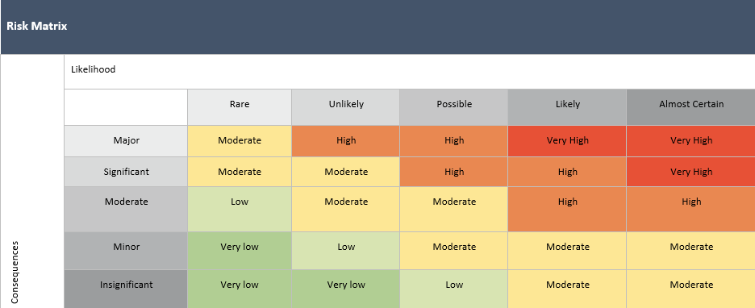

Risk Assessment Communication Record -
Date of Review: | Person/s who completed Review: |  | Date of Review: | Person/s who completed Review:
Changes Made: YES / NO |  |  | Changes Made: YES / NO
Notes: |  |  | Notes:
Educator/Staff Name | I have read and understood this Risk Assessment (tick) | Date & Signature | Educator/Staff Name | I have read and understood this Risk Assessment (tick) | Date & Signature

