Risk Rating Key
Very Low/ Low/ Moderate / High / Very High

Activity | Hazard | Risk Assessment  (use Matrix) | Control Measure |  | Who | When
Using hand tools | Breaks, strains or fractures from incorrect use or impact | Moderate | • Use age-appropriate tools and materials.  • Children instructed not to swing, throw or misuse tools.  • Ensure children have adequate personal space.  • Educators assist children who are not confident or require additional support.  • Stop activity immediately if unsafe practice is observed.  • First aid kit readily accessible. |  | All educators / Responsible Person | Throughout activity
Using hammer, nails and other tools | Cuts, punctures or abrasions from sharp tools/materials | Moderate | • Inspect tools before use and remove damaged or unsafe equipment.  • Demonstrate safe handling and carrying of tools.  • Children must not run while carrying tools.  • Tools used only in designated activity area.  • Educators maintain active supervision.  • Appropriate PPE used where required.  • First aid kit readily accessible. |  | All educators / Responsible Person | Throughout activity
Hammering nails/materials | Nails becoming lodged in fingers/hands | Moderate | • Demonstrate safe positioning of hands and fingers before hammering.  • Educators assist children with positioning materials where required.  • Use a suitable method to initially position nails rather than holding nails close to the striking area where possible.  • Only suitable nails and materials are used.  • First aid provided promptly for any puncture injury. |  | All educators / Responsible Person | Throughout activity
Hammering/material manipulation | Flying nails, fragments, splinters or objects causing eye/face injury | Moderate | • Secure materials before hammering.  • Maintain appropriate spacing between children.  • Safety glasses provided and worn where appropriate.  • Educators monitor children's positioning.  • Children must not stand directly beside or in front of another child who is hammering. |  | All educators / Responsible Person | Throughout activity
Using tools/materials | Splinters from wood/materials | Low/Moderate | • Inspect timber and other materials before use.  • Remove materials with significant splinters or sharp edges.  • Sand rough edges where appropriate.  • Children wash hands after activity.  • Educators monitor materials throughout the activity. |  | All educators | Before and throughout activity
Using tools | Choking hazard from small nails, screws, fragments or loose pieces | Moderate | • Small components assessed for suitability based on children's ages and developmental abilities.  • Small loose parts not accessible to children who may mouth objects.  • Children reminded that tools and materials must never be placed in their mouths.  • Educators maintain close supervision.  • Small components counted and secured before and after activity.  • Area thoroughly checked and cleaned before children leave. |  | All educators / Responsible Person | Before, throughout and after activity
Using tools and materials | Damage to tables, floors, walls or other surfaces | Low | • Activity conducted on an appropriate, stable and protected work surface.  • Protective mats/boards used where required.  • Tools not used directly on breakable, fragile or unsuitable surfaces.  • Educators check setup before children begin. |  | Responsible Person / All educators | During setup and throughout activity
Tools/materials | Tools left unattended or accessible to children when not in use | Moderate | • Tools remain under educator supervision at all times.  • Tools counted/checked before and after activity.  • Tools stored securely when not actively being used.  • Children do not access tool storage area.  • Activity area packed away immediately after completion. |  | All educators / Responsible Person | Throughout and immediately after activity
Tools | Inappropriate, damaged or unsuitable tools | Low/Moderate | • Educators inspect all tools before use.  • Damaged, broken, rusty or unsuitable tools immediately removed from service.  • Use lightweight, non-electric, age-appropriate tools only unless separately risk assessed.  • Consider children's individual abilities and additional needs when selecting tools. |  | Responsible Person / All educators | Before activity
Screwdriver use | Screwdriver slipping and causing puncture/cut injury | Moderate | • Demonstrate correct grip and use.  • Use appropriately sized screwdrivers.  • Materials secured before children begin.  • Children instructed to keep their free hand away from the area being worked on.  • Educators provide assistance where required. |  | All educators | Throughout activity
Sandpaper use | Skin irritation, abrasions or dust exposure | Low/Moderate | • Use appropriate-grade sandpaper.  • Avoid excessive rubbing that may cause skin injury.  • Children wash hands after use.  • Avoid creating excessive dust.  • Ensure activity occurs in a well-ventilated area.  • PPE considered where dust is generated. |  | All educators | Throughout activity
Loose parts / old technology / recycled materials | Chemical burns or exposure from leaking/corroded batteries | Moderate | • Educators inspect recycled materials, old technology and loose parts for batteries, leakage or corrosion before setup.  • Children must not handle leaking or corroded batteries/materials.  • Educators use appropriate PPE when removing unsafe materials where safe to do so.  • Unsafe items removed from activity immediately.  • Materials with unidentified chemical residue or significant corrosion are not used. |  | Responsible Person / All educators | Before setup and throughout activity
Activity setup | Trip/slip hazards from tools, materials or equipment | Low/Moderate | • Keep tools and materials within designated work area.  • Bags, cords and unnecessary equipment removed from walkways.  • Maintain clear access and emergency exit pathways.  • Clean spills and loose materials immediately.  • Complete final area checks before children move to another activity. |  | All educators | Throughout and after activity
Activity | Inadequate supervision / unsafe behaviour | Moderate | • Maintain required educator-to-child ratios.  • Educator must be present and actively supervising while tools are being used.  • Educators position themselves to see, hear and respond to all children.  • Safety rules discussed before activity.  • Unsafe or inappropriate use results in immediate removal from activity.  • Children must follow educator instructions at all times. |  | All educators / Responsible Person | Throughout activity
Activity | Child unable to safely use tools due to age, ability or confidence | Moderate | • Assess individual children's developmental abilities before participation.  • Provide additional educator assistance where required.  • Offer alternative activities where a child cannot safely participate.  • Adjust tools/materials to suit individual needs.  • Do not pressure a child to participate if they are unable to safely use equipment. |  | All educators | Before and throughout activity
Activity completion | Loose nails, sharp fragments or small pieces remaining in activity area | Moderate | • Educators complete thorough cleanup immediately after activity.  • Nails, screws and other small components counted and secured.  • Sweep/check floor and surrounding surfaces for sharp or loose materials.  • Children remain away from activity area until it has been declared safe.  • Tools returned to secure storage. |  | All educators / Responsible Person | Immediately after activity
Emergency response | Injury requiring first aid or emergency response | Moderate | • Staff familiar with Emergency Procedures Manual and relevant service procedures.  • First aid kit fully stocked and readily accessible.  • Educators maintain required first aid qualifications.  • Injuries assessed and first aid provided promptly.  • Parents/carers notified in accordance with service procedures.  • Incidents/injuries documented and reported as required.  • Emergency services contacted where required. |  | Responsible Person / First Aid Qualified Educator | Immediately if required
Completed by: Leesa Mantzos  Signature: Date: 20.8.26 |  |  |  | Approved By:  Signature: Date:

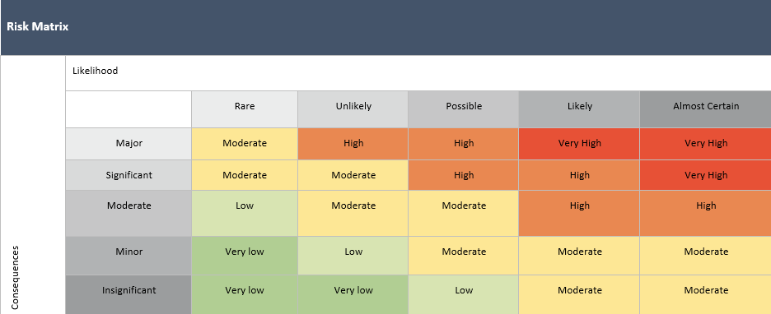

Risk Assessment Communication Record -
Date of Review:  20.8.26 | Person/s who completed Review:  Leesa Mantzos |  | Date of Review: | Person/s who completed Review:
Changes Made: YES / NO |  |  | Changes Made: YES / NO
Notes: New format, areas re-worded and new control measures. |  |  | Notes:
Educator/Staff Name | I have read and understood this Risk Assessment (tick) | Date & Signature | Educator/Staff Name | I have read and understood this Risk Assessment (tick) | Date & Signature

