Risk Rating Key
Very Low/ Low/ Moderate / High / Very High

Activity | Hazard | Risk Assessment  (use Matrix) | Control Measure |  | Who | When
Water Play Activities | Slips, trips and falls on wet surfaces resulting in sprains, fractures, bumps, bruises and grazes | Likelihood: Possible Consequence: Moderate Risk Rating: High | Safety checklist completed prior to activity. Activity conducted on suitable surface free from hazards and obstructions. Educators monitor wet areas and modify activity if excessive pooling occurs. Children wear enclosed footwear. Running rules discussed and reinforced. |  | All Educators | Before and during activity
Water Play Activities | Collision between children during active play | Likelihood: Possible Consequence: Moderate Risk Rating: Medium | Large play space selected. Activities spaced away from other games and equipment. Educators actively supervise and intervene where play becomes unsafe. |  | All Educators | During activity
Water Play Activities | Water-related incident or unsafe behaviour around water equipment | Likelihood: Unlikely Consequence: Major Risk Rating: High | Continuous active supervision maintained. Clear water play rules discussed before commencement. Unsafe behaviour results in removal from activity. Water containers emptied immediately after use. No child permitted to place head over or inside buckets, tubs or containers. |  | All Educators | During activity
Water Play Activities | Sunburn, heat exhaustion, heat stress, dehydration or sunstroke | Likelihood: Possible Consequence: Major Risk Rating: High | UV levels checked prior to activity. Children and educators wear hats when UV is 3 or above. Sunscreen applied at least 20 minutes prior to activity and reapplied as required. Drinking water readily available. Regular water breaks encouraged. Activity modified or ceased during extreme heat conditions. |  | All Educators | Before and during activity
Water Play Activities | Hypothermia or excessive cooling from prolonged exposure to water and weather conditions | Likelihood: Unlikely Consequence: Moderate Risk Rating: Medium | Weather monitored throughout activity. Duration of water play adjusted according to conditions. Children dried promptly and changed into dry clothing if required. Activity ceased if children become excessively cold or distressed. |  | All Educators | During activity
Water Play Activities | Asthma, allergic reactions or medical emergency | Likelihood: Possible Consequence: Major Risk Rating: High | Educators review Medical Management Plans prior to activity. First Aid Kit, Ventolin, spacer and medication accompany group. Educators follow medical management and emergency procedures. |  | All Educators | Before and during activity
Water Play Activities | Insect bites, stings, welts and skin irritation | Likelihood: Possible Consequence: Minor Risk Rating: Medium | Play area checked for insect nests, bindis, weeds and hazards. Children monitored for allergic reactions and irritation. First aid administered where required. |  | All Educators | Before and during activity
Water Play Activities | Unsafe weather conditions including storms, lightning or extreme heat | Likelihood: Unlikely Consequence: Major Risk Rating: High | Weather forecasts monitored before and during activity. Activity suspended immediately during lightning, storms or unsafe weather conditions. Children moved to a safe indoor environment. |  | Responsible Person / Educators | Before and during activity
Water Play Activities | Communication delays during an emergency | Likelihood: Unlikely Consequence: Moderate Risk Rating: Medium | Walkie-talkies and work mobile phone accompany group. Emergency contact information accessible at all times. |  | All Educators | During activity
Water Play Activities | Inadequate supervision | Likelihood: Unlikely Consequence: Major Risk Rating: High | Educator-to-child ratios maintained at all times. Active supervision strategies including PAT (Position, Awareness and Teamwork) implemented. Educators strategically positioned to observe all children. |  | All Educators | At all times
Water Play Activities | Slips, trips and falls on wet surfaces resulting in sprains, fractures, bumps, bruises and grazes | Likelihood: Possible Consequence: Moderate Risk Rating: High | Safety checklist completed prior to activity. Activity conducted on suitable surface free from hazards and obstructions. Educators monitor wet areas and modify activity if excessive pooling occurs. Children wear enclosed footwear. Running rules discussed and reinforced. |  | All Educators | Before and during activity
Water Play Activities | Collision between children during active play | Likelihood: Possible Consequence: Moderate Risk Rating: Medium | Large play space selected. Activities spaced away from other games and equipment. Educators actively supervise and intervene where play becomes unsafe. |  | All Educators | During activity
Water Play Activities | Water-related incident or unsafe behaviour around water equipment | Likelihood: Unlikely Consequence: Major Risk Rating: High | Continuous active supervision maintained. Clear water play rules discussed before commencement. Unsafe behaviour results in removal from activity. Water containers emptied immediately after use. No child permitted to place head over or inside buckets, tubs or containers. |  | All Educators | During activity
Water Play Activities | Sunburn, heat exhaustion, heat stress, dehydration or sunstroke | Likelihood: Possible Consequence: Major Risk Rating: High | UV levels checked prior to activity. Children and educators wear hats when UV is 3 or above. Sunscreen applied at least 20 minutes prior to activity and reapplied as required. Drinking water readily available. Regular water breaks encouraged. Activity modified or ceased during extreme heat conditions. |  | All Educators | Before and during activity
Water Play Activities | Hypothermia or excessive cooling from prolonged exposure to water and weather conditions | Likelihood: Unlikely Consequence: Moderate Risk Rating: Medium | Weather monitored throughout activity. Duration of water play adjusted according to conditions. Children dried promptly and changed into dry clothing if required. Activity ceased if children become excessively cold or distressed. |  | All Educators | During activity
Water Play Activities | Asthma, allergic reactions or medical emergency | Likelihood: Possible Consequence: Major Risk Rating: High | Educators review Medical Management Plans prior to activity. First Aid Kit, Ventolin, spacer and medication accompany group. Educators follow medical management and emergency procedures. |  | All Educators | Before and during activity
Water Play Activities | Insect bites, stings, welts and skin irritation | Likelihood: Possible Consequence: Minor Risk Rating: Medium | Play area checked for insect nests, bindis, weeds and hazards. Children monitored for allergic reactions and irritation. First aid administered where required. |  | All Educators | Before and during activity
Water Play Activities | Unsafe weather conditions including storms, lightning or extreme heat | Likelihood: Unlikely Consequence: Major Risk Rating: High | Weather forecasts monitored before and during activity. Activity suspended immediately during lightning, storms or unsafe weather conditions. Children moved to a safe indoor environment. |  | Responsible Person / Educators | Before and during activity
Water Play Activities | Communication delays during an emergency | Likelihood: Unlikely Consequence: Moderate Risk Rating: Medium | Walkie-talkies and work mobile phone accompany group. Emergency contact information accessible at all times. |  | All Educators | During activity
Water Play Activities | Inadequate supervision | Likelihood: Unlikely Consequence: Major Risk Rating: High | Educator-to-child ratios maintained at all times. Active supervision strategies including PAT (Position, Awareness and Teamwork) implemented. Educators strategically positioned to observe all children. |  | All Educators | At all times
Completed by: Leesa Mantzos  Signature: Date: 02.06.2026 |  |  |  | Approved By:  Signature: Date:
Relevant NQS and Legislative Links: *Quality Area 2 – Children's Health and Safety *Element 2.1.1 Wellbeing and Comfort *Element 2.1.2 Health Practices and Procedures *Element 2.2.1 Supervision *Element 2.2.2 Incident and Emergency Management *Element 2.2.3 Child Protection *Education and Care Services National Regulations 77, 85, 97, 100 and 168 *Child Safe Standards

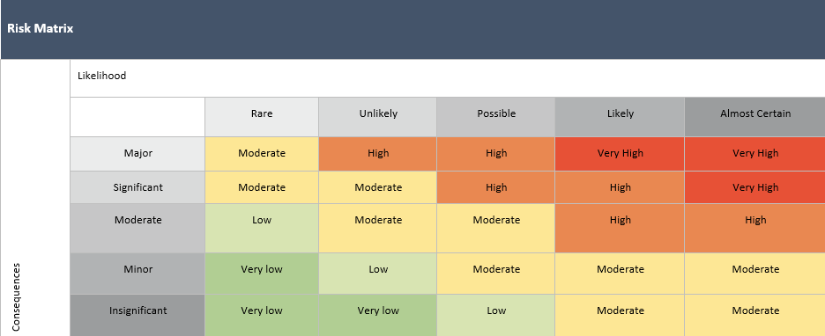
Risk Assessment Communication Record -
Date of Review:  02.06.26 | Person/s who completed Review: Leesa Mantzos |  | Date of Review: | Person/s who completed Review:
Changes Made: YES / NO |  |  | Changes Made: YES / NO
Notes: Updated to new Format, Additional Control Measures  *First Aid trained educators present during all water play activities.  *Emergency evacuation bag accompanies the group.  *Children reminded of service expectations including Be Safe, Be Responsible and Be Respectful.  *Water play equipment inspected prior to use.  *Standing water removed immediately following completion of the activity.  *Incident, injury or near-miss reports completed where required. |  |  | Notes:
Educator/Staff Name | I have read and understood this Risk Assessment (tick) | Date & Signature | Educator/Staff Name | I have read and understood this Risk Assessment (tick) | Date & Signature

