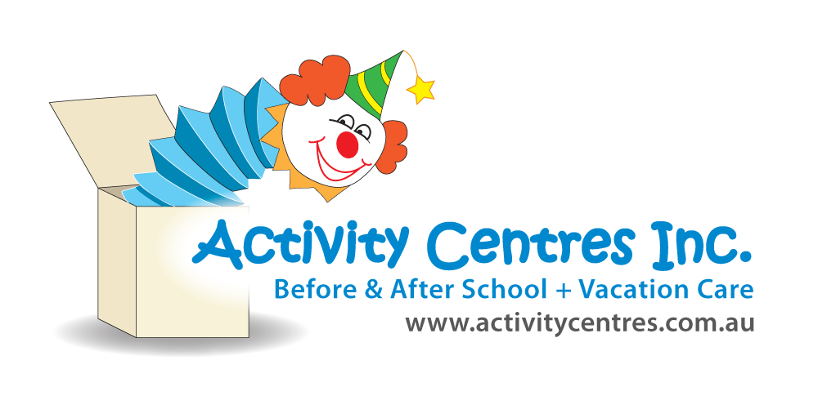
Risk Rating Key
!! Very High
! High Risk
# Medium Risk
* Low Risk
Wheeled Toy's : Risk Assessment
Toongabbie West Activity Centre
Identified Hazard –
- Falling off wheeled toy
- Colliding with other children
- Tripping on sticks, debris etc while riding
- Member of public approaching children/staff
- Stray or leashed dogs
- Litter from public (sharps, rubbish, glass)
- Loss of communication
- Inclement weather
Risk | Control Measure  Staff will be required to read the Emergency Procedures Manual in consultation with this Risk Assessment.
* Unable to communicate with Coordinator/Educators | - As per our Emergency Procedures Manual & Flip Chart – 3.3 to 3.6 Evacuation and Flip Chart  - ECO (Emergency Control Organisation) - Responsible Person to delegate each position to a Staff person at beginning of each Session.  - Staff are to be aware of their roles and responsibilities on the ECO.  - Educators and children to be aware of Primary and Secondary Assembly Points.  Emergency Planning Committee (EPC) meet annually.
! Contracting of diseases  !! Allergic and or Anaphylactic Reaction | - As per our Emergency Procedures Manual & Flip Chart – 3.12 Medical Emergency & 3.23 Needle Stick Injury & Syringe Disposal  - Children that have Asthma, Allergies or Anaphylaxis Action Plans, depending on RMP will have their Medication Box taken.  - Educators are aware and understand procedures to be followed.
! Bite/mauling  ! Child Protection Issues | - As per our Emergency Procedures Manual & Flip Chart – 3.17 Robbery & Personal Threat  - Keep still and do not make sudden moves.  - Do not use phone in perpetrator’s presence.  - Obey perpetrator’s instructions.  - Observe perpetrator’s appearance.  - Allow perpetrator to leave but do not follow.  - Educators are to ensure children stay in designated area and not engage in conversations with strangers.  - Children are not to approach any animal unless an Educator has determined it is safe (would be acceptable for a child's pet)  - If an Educator has determined it is safe children will be shown how to correctly touch, approach, hold and act around the animal.  - Educators have regular discussions formally (during practice lock down and evacuation drills) and informally. During these we discuss serious incidents involving different types of animals. E.g spiders, snakes, dogs etc.  - If the animal is deemed unsafe and the Educator is unsure, either a lock down or evacuation is to commence.  - Educators are to be aware and understand procedures to be followed.
- As per our Emergency Procedures Manual and Flip Chart – 3.19 & 3.20 Natural Disasters & External Emergencies
- In extreme weather conditions children will be unable to ride their wheeled toys e.g. rain, hail, storm, windstorm, extreme heat.
- Bike circuit can be setup in quad are with 4-5 children riding at one time to eliminate congestion.

!! Children being abducted/leaving area | - As per our Emergency Procedures Manual and Flip Chart – 3.22 Missing Child  - Search immediate area.  - Chief Warden to coordinate searchers and search area.  - If missing child not found within reasonable time refer to Absent and Missing children Policy.  - Notify NSW Police.  - Notify parents.
! Concussion  # Pain and itching  ! !! Cuts, scrapes, bruises  ! !! Broken bones, fractures, sprains, strains  ! !! Tripping, falling, slipping onto concrete  * Unable to communicate with Coordinator/Educators | - As per our Policies and Procedures, Education and Care Services National Regulations and Law and WHS Regulations and Law  - Responsible Person to approve area for children to ride their wheeled toys and Educators commence a safety checklist before the children start riding. Areas that children can ride, Multipurpose Court & Handball Quad Area. Check areas have no hazards that can cause trips or slips. Any obstructions need to be recorded and removed. If unsafe the activity is not to go ahead.  - Hazards – Eliminated, sectioned off or totally avoided. Maintenance Log in (SIM) and ACI Hazard Report to be completed and forwarded to School Principal.  - Educators are trained in first aid.  - The emergency trolley is to be taken to the multipurpose court containing the first aid kit, Ventolin kit, emergency contacts for all children and educators.  - Educators are to take walkie talkies/phones with them to communicate with other educators and the work mobile phone to contact parents/Head office/emergency services.  - Educators are to set up the space using cones/bins/chairs to ensure children know where to go.  - New Educators are taught about bike and scooter day, how it will be run and the safety concerns of the activity.  - Children are shown which way to ride to avoid collisions.  - Wheeled toy car wash: children are shown the correct way to clean their wheeled toy by avoiding small areas where their fingers may get caught resulting in a cut, scrape or bruise  - Any children not following the rules will not be permitted to ride for a period of time, if the behaviour continues they will not be permitted to continue to ride for the rest of the day.  - Children must ride their own bike, scooter and not share each other’s wheeled toys.  - If there are lots of children educators will divide them into groups to have turns of riding. Groups should be based on children’s capabilities (e.g. k-2 and 3-6 go together).  - Educators and children are to wear hats and sunscreen if the UV is 3 and over. Educators are to check the SunSmart App regularly. Sunscreen is to be reapplied every 2 hours if UV is still high.  - Water is available for children to rehydrate.  - Children and educators are to wear enclosed shoes throughout this activity and appropriate clothing covering shoulders (no singlets).  - Children must have their own helmet to ride their bike, scooter or skateboard.  - Red wheeled boards MUST NOT be used without helmets.  - Designated area to be allocated for children to park their bikes and scooters  - Bikes to be wheeled through the veranda and down ramp to the multipurpose court. (not down the stairs)  - Bikes. scooters, rollerblades and skateboards can all be used at the same time; however, the R.P. or supervising staff member must first assess the area where the wheeled activities will take place to ensure it is safe for simultaneous use.  - Wheeled Toys to be parked in a safe space away from Admin Building - (best area is at the back where boys and girls toilets are)  - NO WHEELED TOYS TO BE RIDEN IN SCHOOL HALL
* Unable to communicate with Coordinator/Educators | - As per our Policies and Procedures, Education and Care Services National Regulations and Law and WHS Regulations and Law  - Evacuation Trolley to contain First Aid Kit, Emergency contact details for children and Educators and 4G capable IPad. Staff Sign In Sheets and Visitors Log to be taken.  - If Evacuation is in place, where possible and if safe to do so, Educators will take children’s Medication Boxes (containing Medical Management Plan and Medication).  - Evacuation Trolley Checklist to be completed every Term and documented in SIM.  - Phones, Walkie Talkies & Ipads to be charged for each Session.  - Educator to conduct Safety Checklist at the beginning of each Session.  - Responsible Person to notify Head Office as soon as practicable after incident occurring.
Completed by: Liz Sakeson  Signature: E.S Date: 11/03/2025 |  | Approved By: Georgia Diab  Signature: GD Date: 11/3/25

