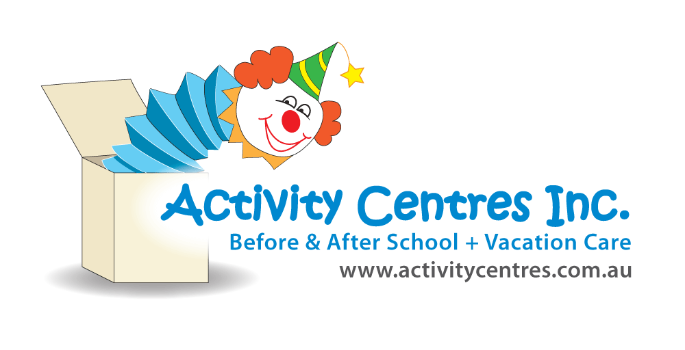

Risk Rating Key

**!! Very High**

**! High Risk**

**# Medium Risk**

**\* Low Risk**

**Identified Hazard** –

* Children handling hot liquids (wax and melted soap)
* Children misusing the microwave
* Too many children in/around the kitchen area
* Supervision not being maintained correctly
* Using resin

**Candle, soap & resin** Risk Assessment

Lapstone Activity Centre

|  |  |  |  |  |
| --- | --- | --- | --- | --- |
| **Risk** | **Control Measures** | | **Person Responsible for taking required action** | **Timeframe for addressing action** |
| Injury to Educators or children  **!**scalding causing blisters or burns | * Safety discussion to occur prior to children taking part in activity that touches on microwave safety, handling hot liquids, kitchen safety (1 person in kitchen at a time), and consequences if safety measures are not followed (children may need to miss out) * One person to use microwave at a time, and an educator to be present when hot liquid is being taken in and out * Small groups of children to complete activity at a time to ensure plenty of space and closer supervision * First aid kit to be fully stocked and readily available, including burn gels * Microwave safe dishes to be used for the use of hot liquids | | All educators  Educator    “ “  Responsible person  Educator | Prior to activity  During activity  “ “  Prior to activity  During activity |
| Microwave issues  **#** Explosion while using microwave  **\***Children pressing incorrect buttons and being to rough with microwave  Kitchen space  **\*** Children bumping into each other  **\***Crowded space, children not having adequate room to complete tasks | * Direct supervision to be maintained whilst children are using the microwave with educator guiding children on what settings/buttons to press * Microwave to be tagged and tested in-line with schedule and not to be used if not tagged and tested * One child using the microwave at a time * Small groups for this activity (3-4) to ensure each child has adequate space to perform the tasks required * One child in the kitchen using the microwave at a time * Other children not participating are asked to move away so they do not impact the safety of children handling hot liquids * Children to take hot liquid from microwave directly to their seating space, an educator to assist if needed, based on the child’s skills and abilities | | All educators  Responsible person  Educator  All educators  “ “  Educators & Children | At all times  Annually  During activity  During activity  “ “  “ “  “ “ |
| Supervision  **#**Children not following safety instructions  **#**Children misusing the equipment | * Educator to be present for assistance and supervision throughout the entirety of this activity * Children found not to be following safety guidelines will be asked to move away and may miss out on activity * Children are not to be left alone when hot liquid is in use * Children’s skills and abilities will be assessed by educators and more assistance may be offered if necessary to ensure safety requirements are followed * Children are showed how to correctly use all equipment involved | | All educators  Children  Educator & Children  Educator | At all times  “ “  “ “  “ “ |
| Resin  **!** Contact with resin on skin (skin irritation)  **!** Ingesting  **!** Fumes become too much | * Children to wear protective equipment, such as gloves and safety goggles * SDS sheets up to date, staff know where to access. * Small groups at a time- max 4 children. One educator to be at activity entire time, running and facilitating * Discussion prior to activity around safety and using materials safely. * If materials are ingested, seek medical advice immediately and call parents * Accessible first aid kit available * Ensure space is well ventilated | | Educators  Responsible person  Educators  “ “  “ “  “ “  “ “ | Prior to activity  Prior to activity  During activity  As needed  Prior to activity |
| Completed by: Jessie McCulloch    Signature: Date: 14/11/2024 | | Approved By: Sean Higgins  Signature: Date: 14/11/2024 | | |

|  |
| --- |
| **Risk Assessment Communication Record for Candle, Soap and resin** |

|  |  |  |  |  |  |
| --- | --- | --- | --- | --- | --- |
| Educator/Staff Name | I have read and understood the above mentioned Risk Assessment (please tick) | Date & Signature | Educator/Staff Name | I have read and understood the above mentioned Risk Assessment  (please tick) | Date & Signature |
|  |  |  |  |  |  |
|  |  |  |  |  |  |
|  |  |  |  |  |  |
|  |  |  |  |  |  |
|  |  |  |  |  |  |
|  |  |  |  |  |  |
|  |  |  |  |  |  |
|  |  |  |  |  |  |
|  |  |  |  |  |  |
|  |  |  |  |  |  |
|  |  |  |  |  |  |
|  |  |  |  |  |  |
|  |  |  |  |  |  |