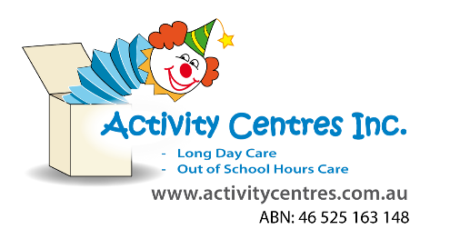
Colour Run : Risk Assessment
Lapstone Activity Centre
Risk Rating Key
!! Very High
! High Risk
# Medium Risk
* Low Risk
Identified Hazard –
- Powder inhalation
- Eye irritation
- Children with asthma
- Slips, trips and falls
- Unsafe behavior
- Heat stroke/sunburn
- Wet weather
Risk  # Irritation to eyes/face | Control Measure  - Children will be reminded to avoid spraying colour in people’s faces.  - Educators will ensure children follow all safety guidelines and rules put in place for the activity.  - Colour powder used is nontoxic.  - Any child who is witnessed to be in any kind of distress or discomfort will be removed immediately. |  | Person Responsible for taking required action  - Coordinator, all educators, RP on shift | Timeframe for addressing action  - When purchasing powder, prior to and throughout session,
# Slips, trips and fall,  ! Breaks and fractures  # Medical conditions such as Asthma | - Educators will ensure that the running space is big enough to minimise children running into each other.  - Educators will utilise adequate supervision whilst children are running.  - Parents/guardians have informed the service of any medical conditions prior to attending.  - A list is kept is clear view to all educators of children who have medical conditions.  - Educators make themselves familiar with asthmatic children who are attending.  - Children with asthma have a puffer kept on premises in an easily accessible place for educators.  - All educators on shift have their first aid certificate and can recognise symptoms of asthma attacks as well as administration of Ventolin. |  | - Coordinator, all educators, RP on shift  “ “ “ “ | - Prior to and throughout session  “ “ “ “
# Unsafe Behaviour  # Heat  stroke/sunburn  wet weather | - If children cannot follow safety guidelines and rules set in place they will be spoken to and warned. If unsafe behaviour continues educators will guide the child to another activity. *Records to be made for behaviour deemed suitable for an incident form.  - RP checklist has been completed prior to session, daily UV has been checked and recorded ensuring educators are aware of the need for hats and sunscreen.  - Children are encouraged to take regular water breaks. Children are encouraged to take their drink bottles with them to the running area.  - Educators will monitor weather throughout session and postpone of pack up the activity if deemed too wet/windy/hot, ect. |  | - Coordinator, all educators, RP on shift | - Prior to and throughout session
Completed by: Sean Higgins  Signature: Date: 30/05/2025 |  | Approved By: Jessie McCulloch  Signature: Date:

Risk Assessment Communication Record for Colour run
Educator/Staff Name | I have read and understood the above mentioned Risk Assessment (please tick) | Date & Signature | Educator/Staff Name | I have read and understood the above mentioned Risk Assessment (please tick) | Date & Signature

