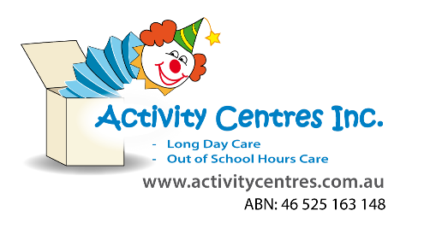
Deconstruction: Risk Assessment
Lapstone Activity Centre
Risk Rating Key
!! Very High
! High Risk
# Medium Risk
* Low Risk
Identified Hazard –
- Hammer
- Small bits of glass
- Screw drivers
- Nails
- Broken wires
- Corroded materials
- Old batteries

Risk  # Bruises from hammer  !! breaks/strains/  fractures  !Cuts/grazes  # Damaging surfaces  *bits of glass getting stuck in fingers  !! Choking hazards  !!nails lodged in finger | Control Measure  Staff will be required to read the Emergency Procedures Manual in consultation with this Risk Assessment.  - Tools to be set up in a safe manner, with lots of space and not on breakable surfaces  - Children who are not confident in using any tools will be assisted by educators  - Educator to always be present whilst tools are in use by the children.  - Safety discussion and rules of use will be discussed with children prior to the use of tools- these include  - sitting/ standing at designated spot where tools have been set up  - using the tools for their intended use  -Inappropriate use will result in immediate removal from activity  - children must follow educator's instructions  - Area must be cleaned/tidied before children move on to ensure no loose bits are left behind  - First aid kit is fully stocked and readily available  - Children are shown how to correctly use each tool- this includes correct way to hold etc.  Staff to assess whether PPE is required for specific activities |  | Person Responsible for taking required action  - Rp on duty/all educators  - Rp on duty/all educators | Timeframe for addressing action  - During setup of activity  - Throughout activity  - As soon as activity is finished
!! Chemical burns from leaking batteries, corroded materials. | - Prior to set up staff are to check any loose parts, old tech etc for any old batteries or corroded materials. If found educators will either remove it themselves using proper PPE or deem the item too unsafe and remove it from the activity to ensure children are not harmed. |  | - Rp on duty/all educators | As soon as activity is finished
Completed by: Sean Higgins  Signature: Date: 30/05/2025 |  | Approved By:  Signature: Date:

Risk Assessment Communication Record for
Educator/Staff Name | I have read and understood the above mentioned Risk Assessment (please tick) | Date & Signature | Educator/Staff Name | I have read and understood the above mentioned Risk Assessment (please tick) | Date & Signature

